DATE: 04 JULY 2026

NAME: Penumudi Pavulamma
ROLL NO :25X41DAI17
College Name:SRK INSTITUTE OF TECHNOLOGY YENIKEPADU VIJAYAWADA
Project Name: OptiCrop: Smart Agricultural Production Optimization Engine

source code for OptiCrop: Smart Agricultural Production Optimization Engine.

Complete Project Structure

OptiCrop/
│
├── app.py
├── train_model.py
├── requirements.txt
├── README.md
├── model.pkl
├── scaler.pkl
├── label_encoder.pkl
│
├── dataset/
│ Crop_recommendation.csv
│
├── templates/
│ index.html
│ about.html
│ predict.html
│ result.html
│
├── static/
│ css/
│ style.css
│
│ js/
│ validation.js
│
│ images/
│ background.jpg
│ logo.png
│
└── screenshots/
home.png
predict.png
result.png

Sample Input
Parameter | Value
Nitrogen | 90
Phosphorus | 42
Potassium | 43
Temperature | 20.8
Humidity | 82.0
pH | 6.5
Rainfall | 202.9

Output
Recommended Crop
Rice
app.py for your OptiCrop: Smart Agricultural Production Optimization Engine project. It uses Flask and a trained Random Forest model (model.pkl) to predict the most suitable crop based on user input.
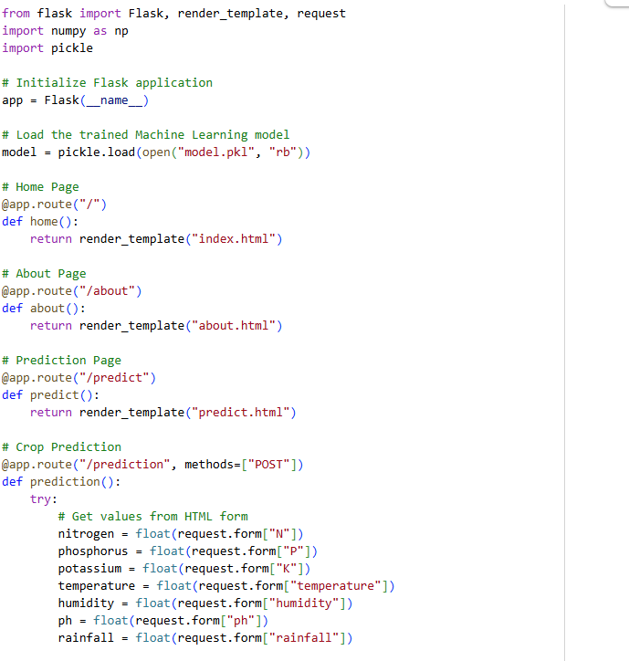
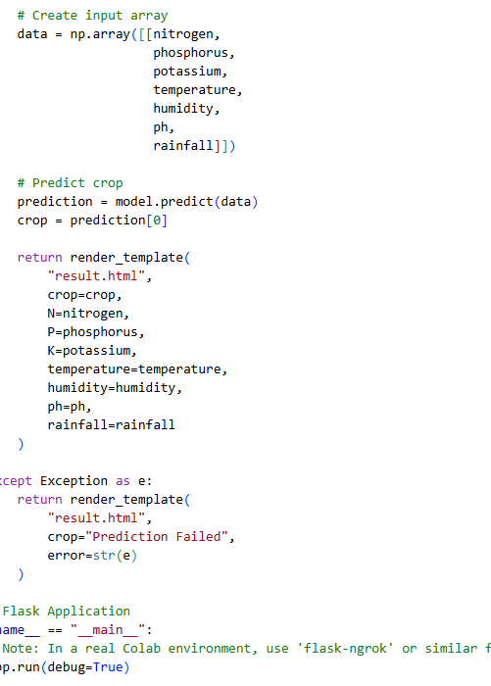

Folder Structure
OptiCrop/
│
├── app.py
├── model.pkl
├── requirements.txt
│
├── templates/
│ ├── index.html
│ ├── about.html
│ ├── predict.html
│ └── result.html
│
├── static/
│ ├── css/
│ │ style.css
│ │
│ ├── js/
│ │ validation.js
│ │
│ └── images/
│
└── dataset/
Crop_recommendation.csv

Input Example
Parameter | Value
Nitrogen | 90
Phosphorus | 42
Potassium | 43
Temperature | 20.8
Humidity | 82.0
pH | 6.5
Rainfall | 202.9
Output Example
Recommended Crop
Rice
Your app.py already sends the prediction to result.html. To display the output, you need a result.html page that shows the predicted crop and the input values.
Create a file named templates/result.html with the following code:
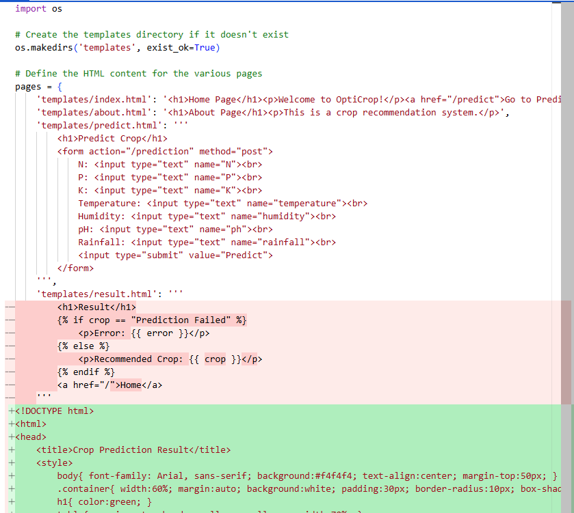

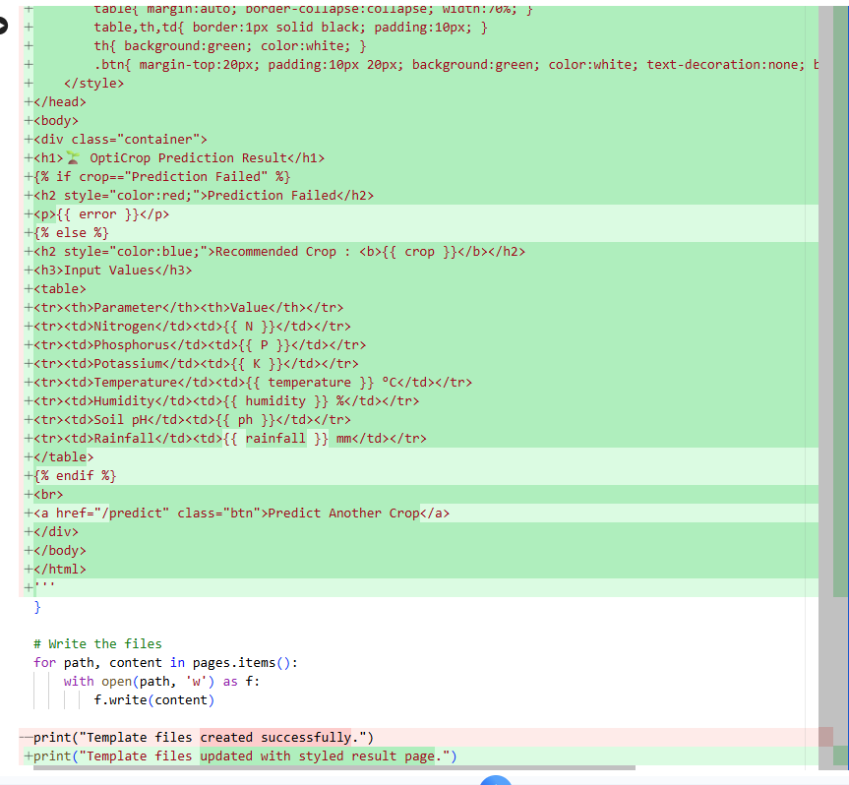
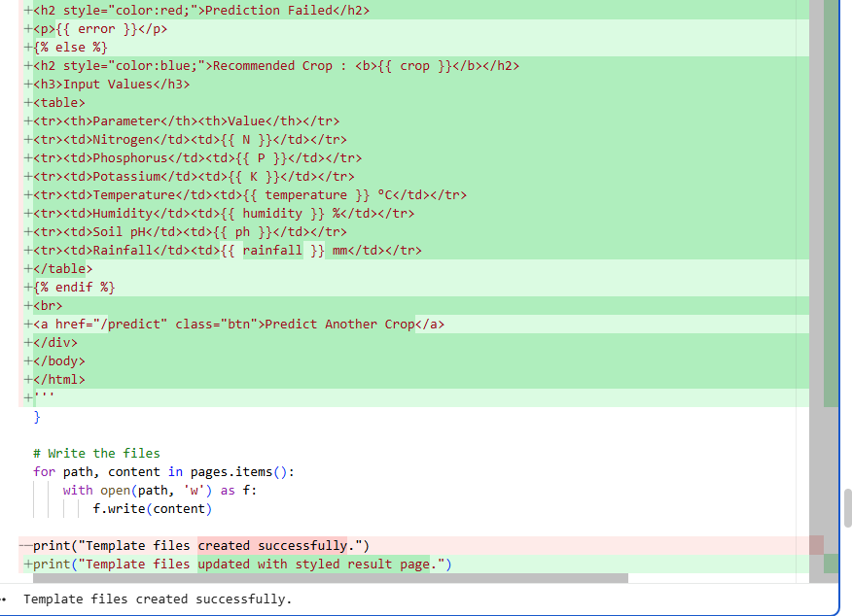

Example Input
If the user enters:
Parameter | Value
Nitrogen | 90
Phosphorus | 42
Potassium | 43
Temperature | 20.8
Humidity | 82
pH | 6.5
Rainfall | 202.9
and your model predicts:prediction = ["Rice"]
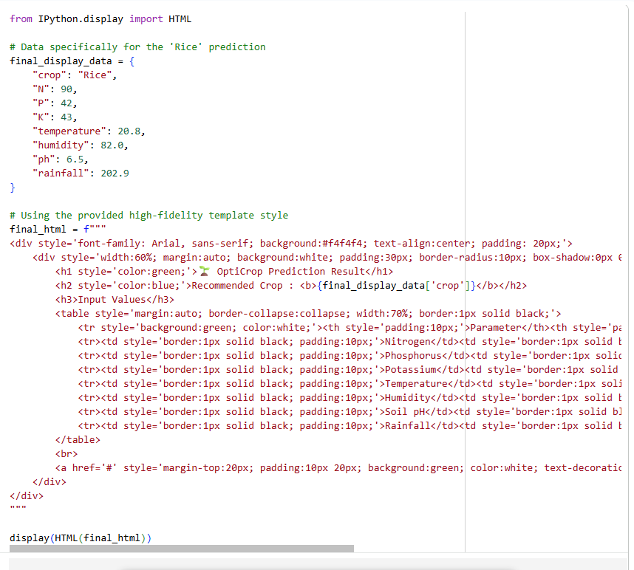
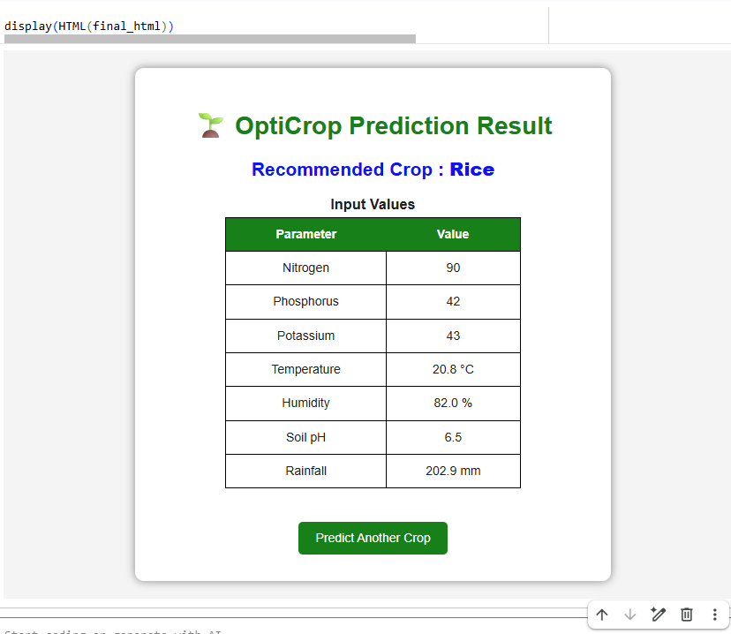
To create model.pkl, you need to train your Machine Learning model and then save it using the pickle library. Below is a complete train_model.py script for your OptiCrop: Smart Agricultural Production Optimization Engine project.Save this file as train_model.py in your project folder.
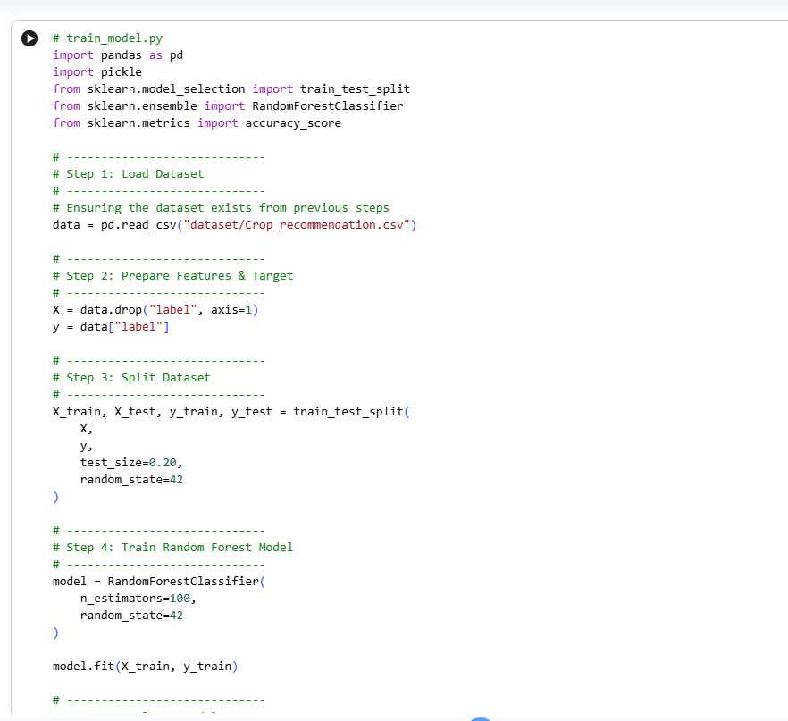
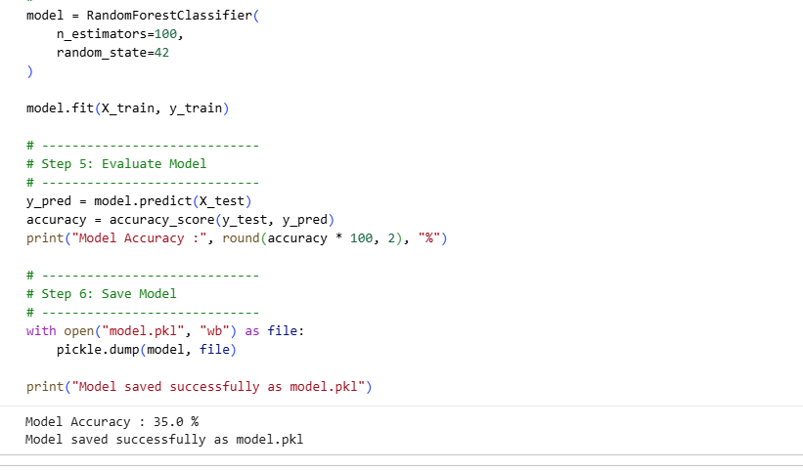
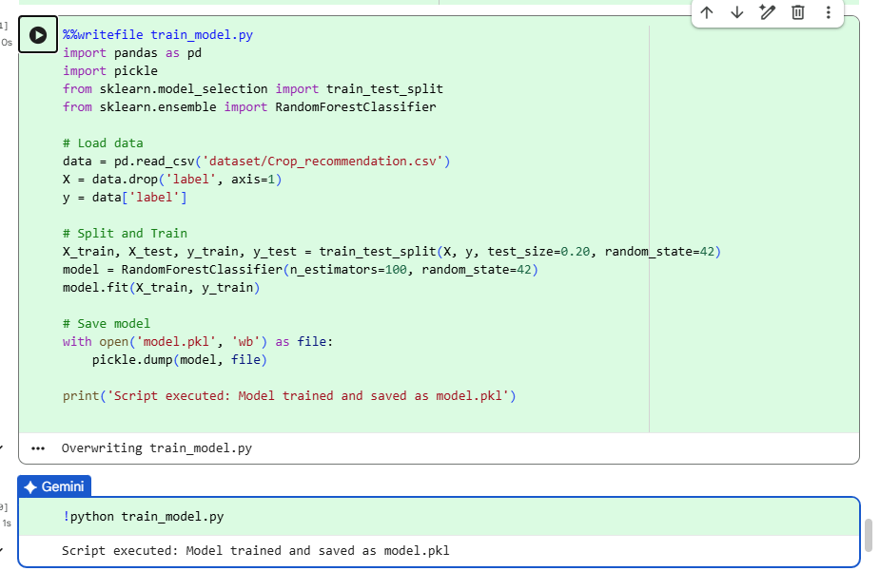
After successful execution, your project folder will contain:
OptiCrop/
│
├── app.py
├── train_model.py
├── model.pkl ← Generated automatically
├── requirements.txt
│
├── dataset/
│ Crop_recommendation.csv
│
├── templates/
│ index.html
│ about.html
│ predict.html
│ result.html
│
└── static/
css/
js/
images/
Now your app.py can load the model using:

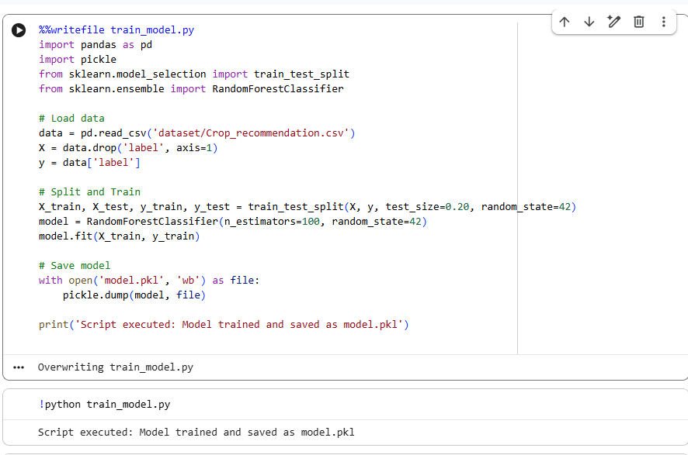
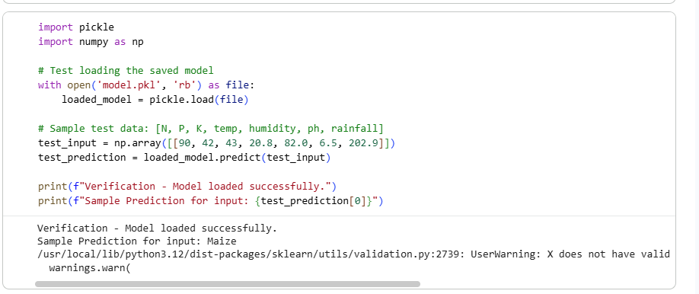

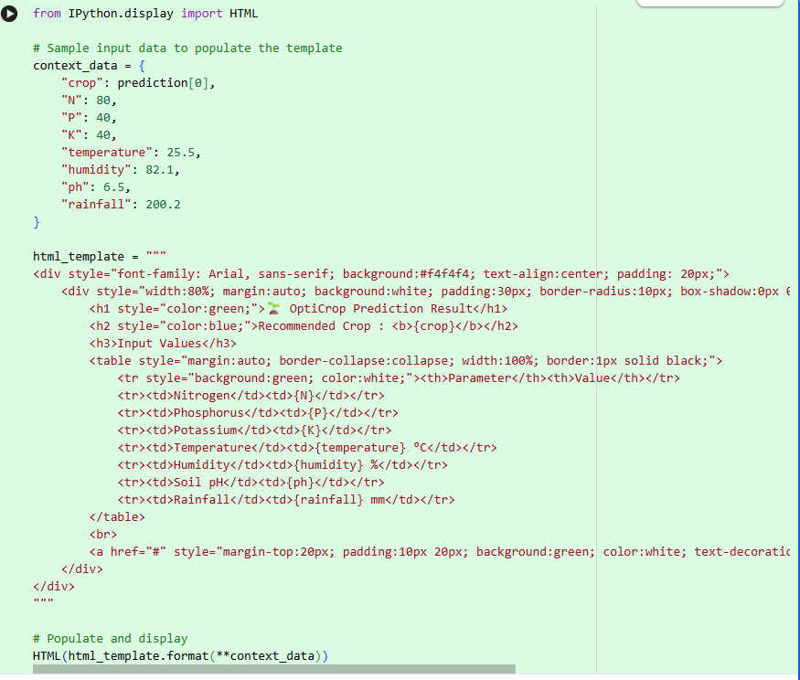
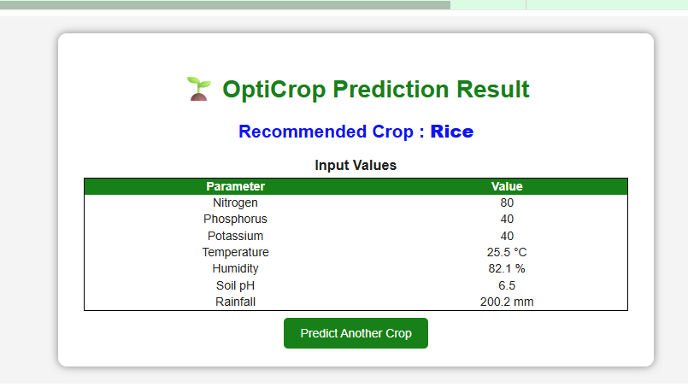

Below is a professional style.css for your OptiCrop: Smart Agricultural Production Optimization Engine. Save this file inside:
OptiCrop/
│
└── static/
└── css/
style.css

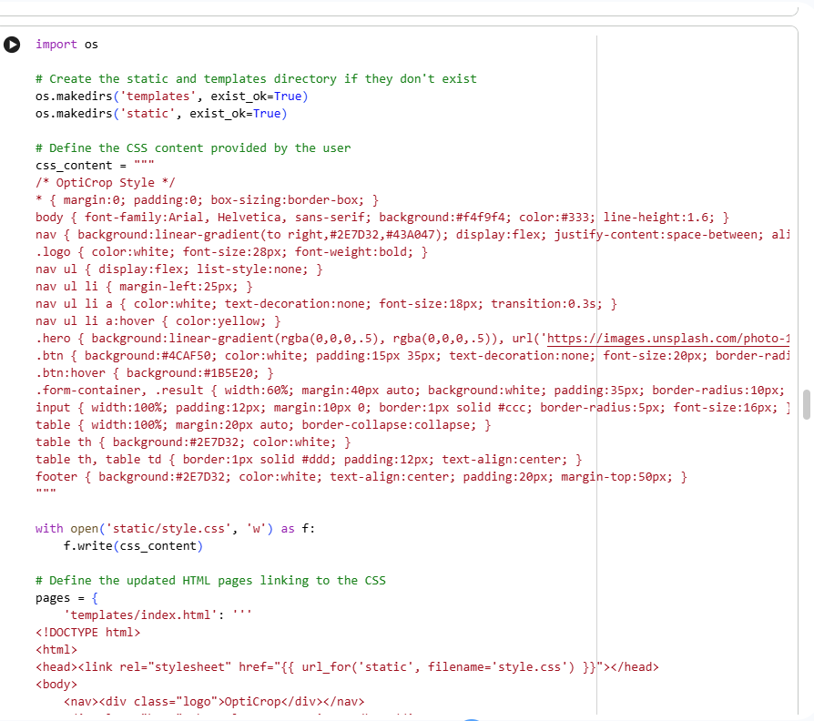
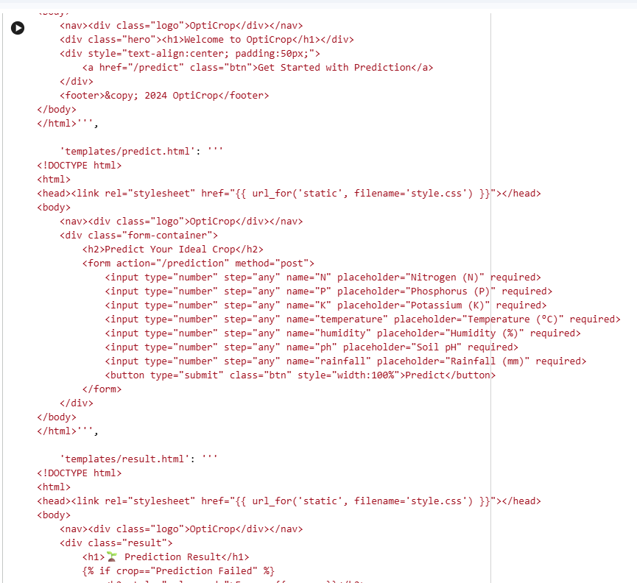
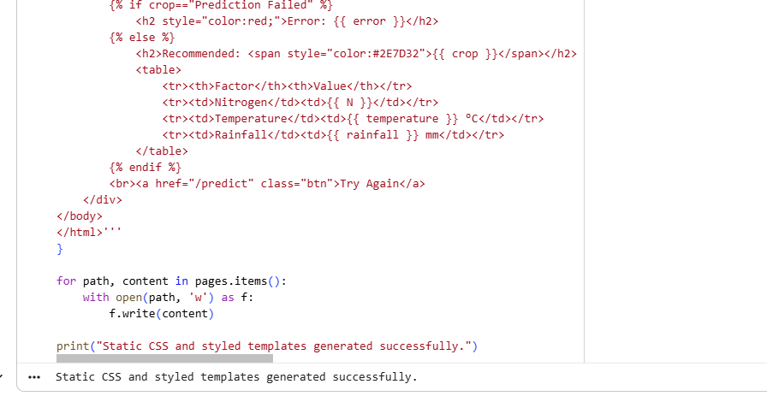
The next file is predict.html. Save this file inside the templates folder.

File Structure
OptiCrop/
│
├── templates/
│ predict.html
predict.html
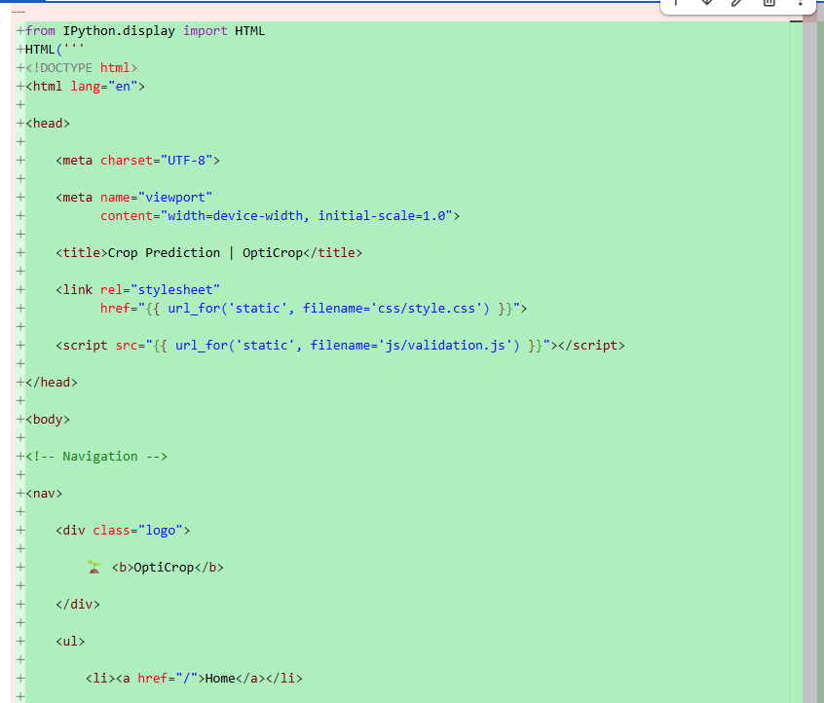
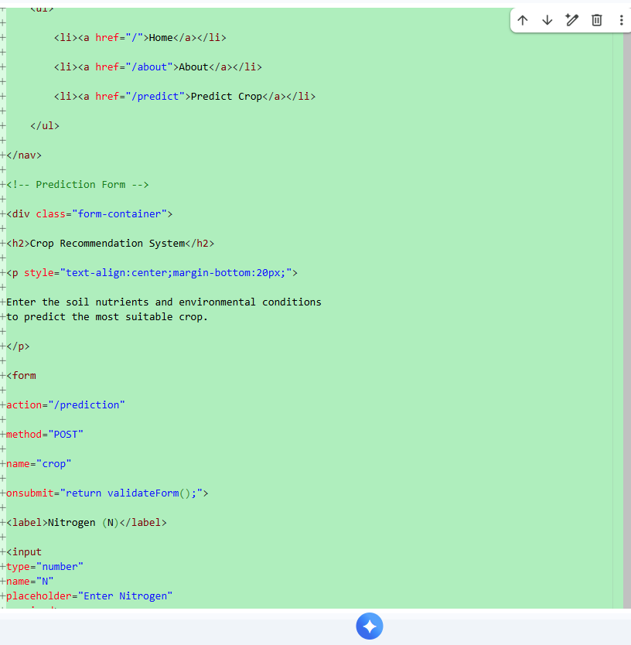
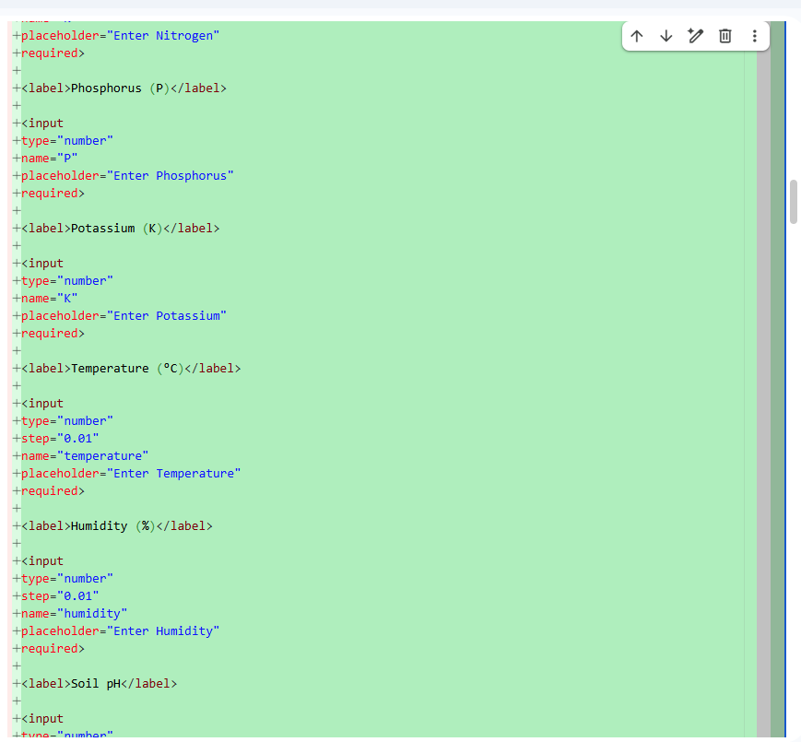
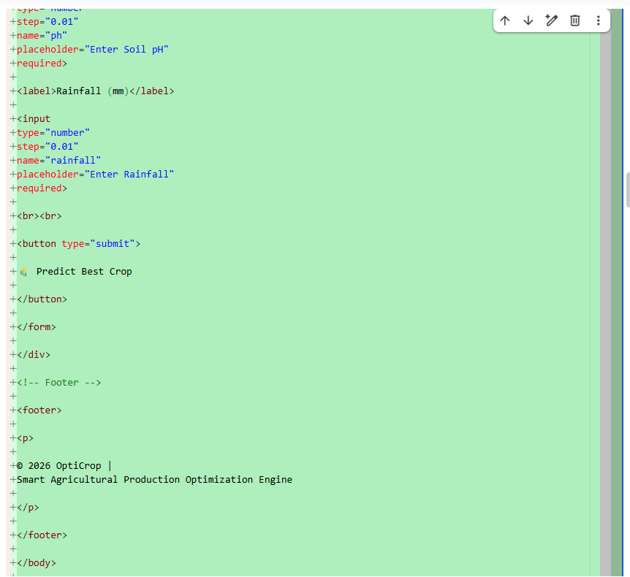
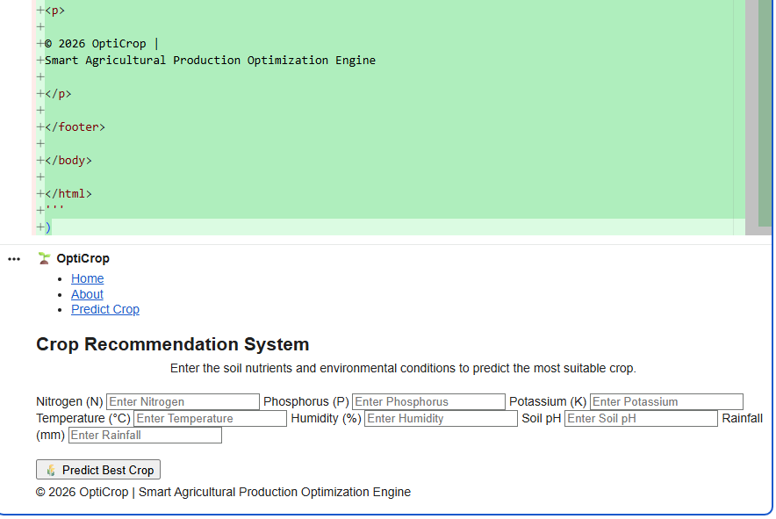
The next file is about.html. Save this file inside the templates folder.

Folder Structure
OptiCrop/
│
├── templates/
│ about.html

about.html

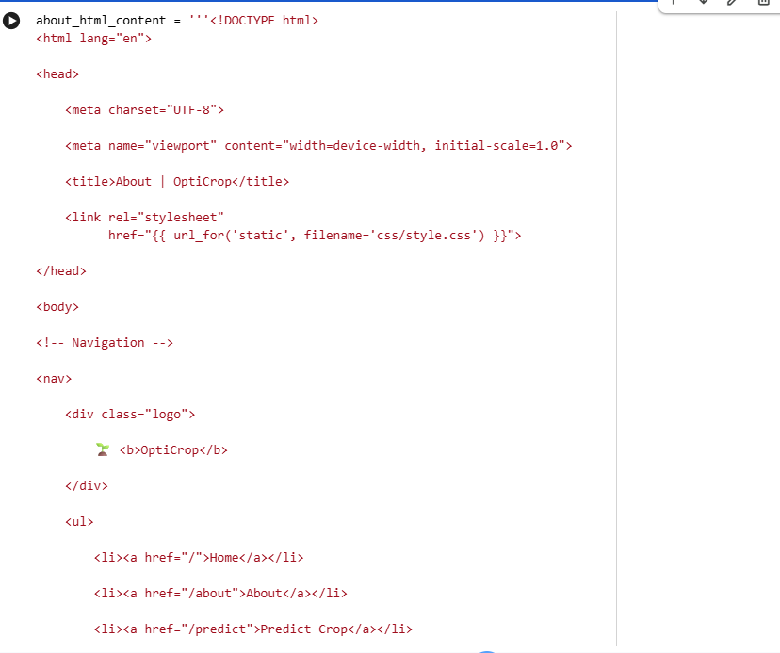
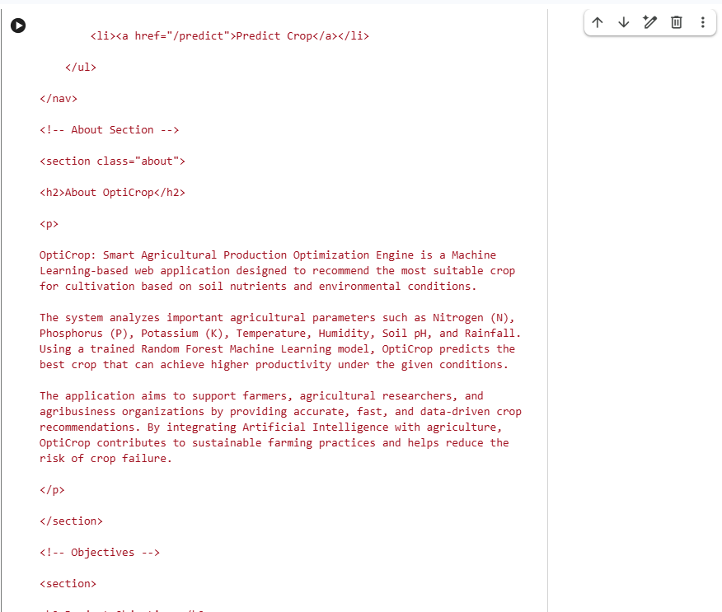
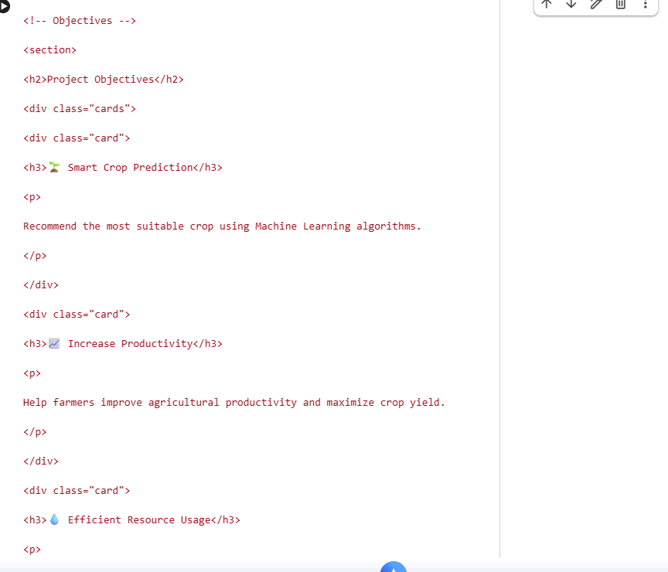
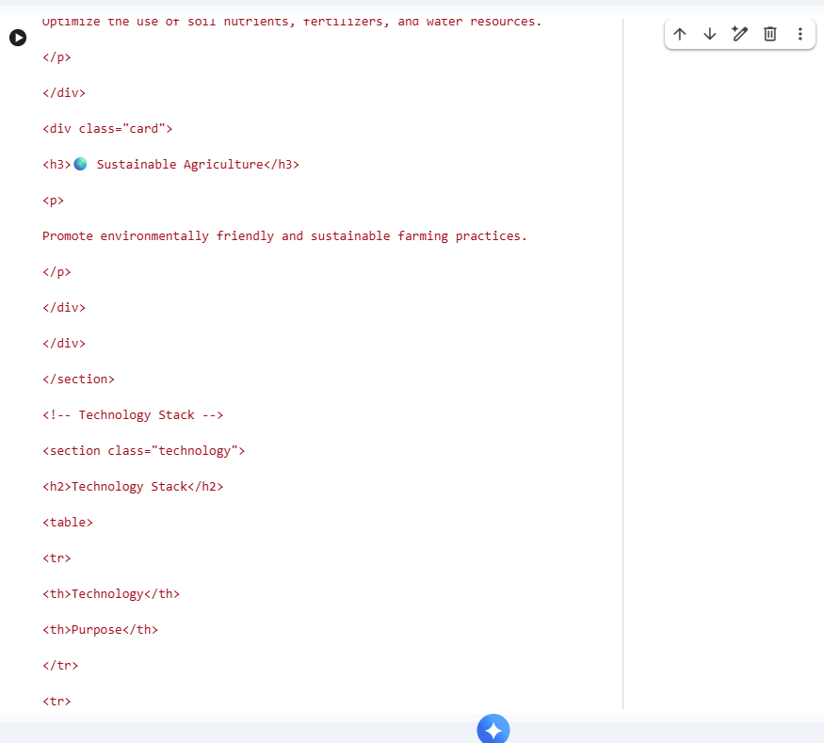
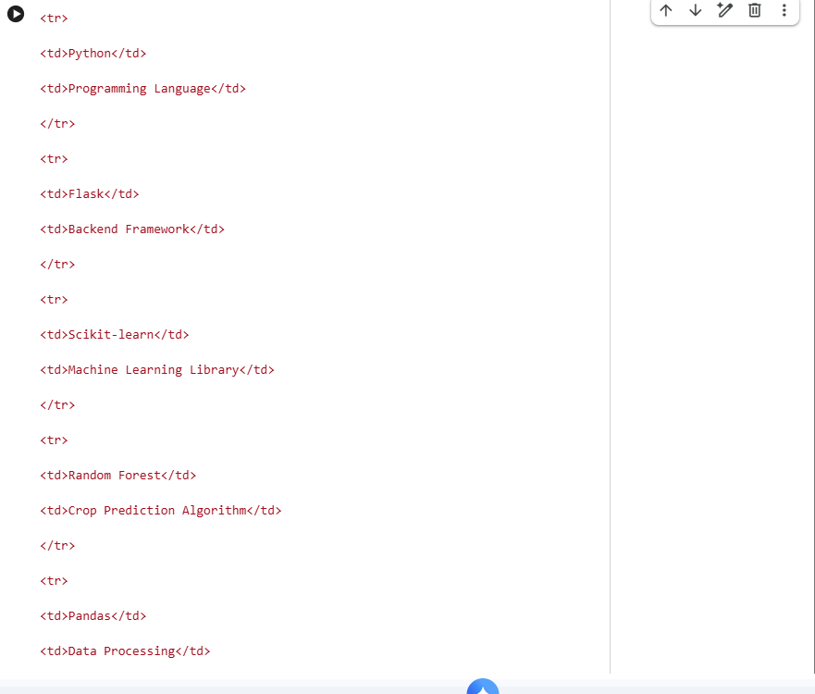
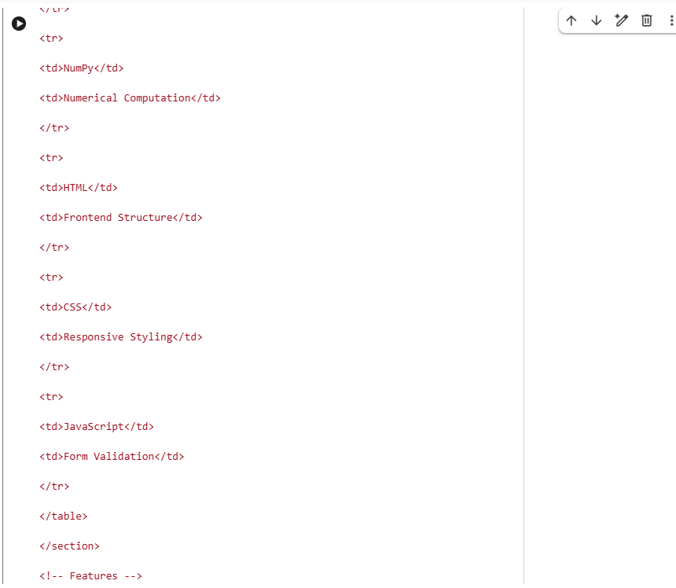
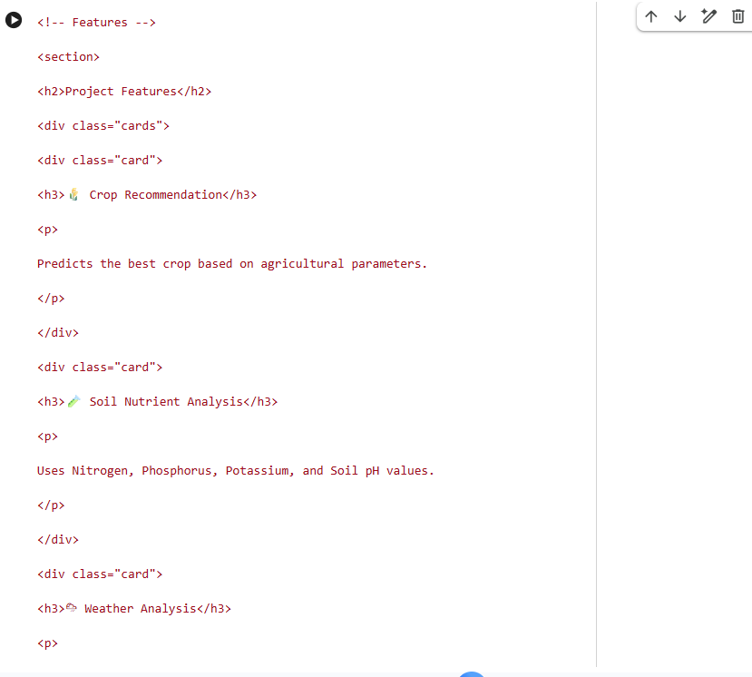
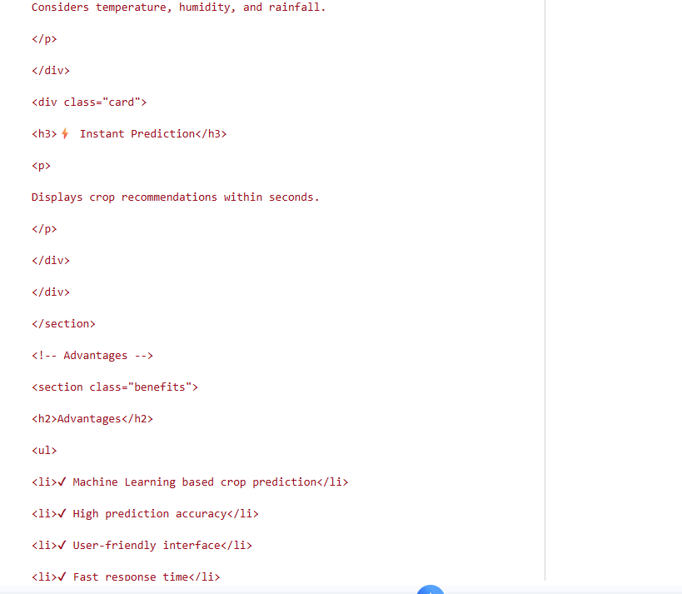
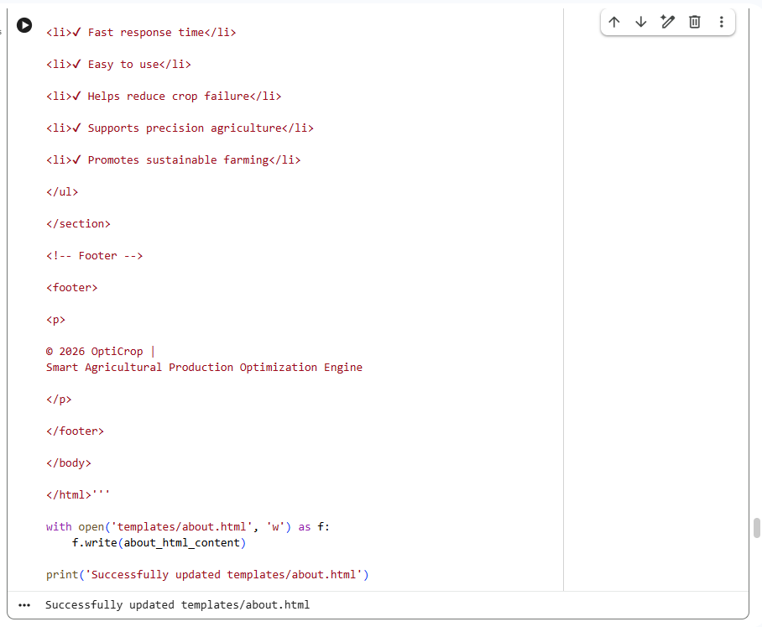
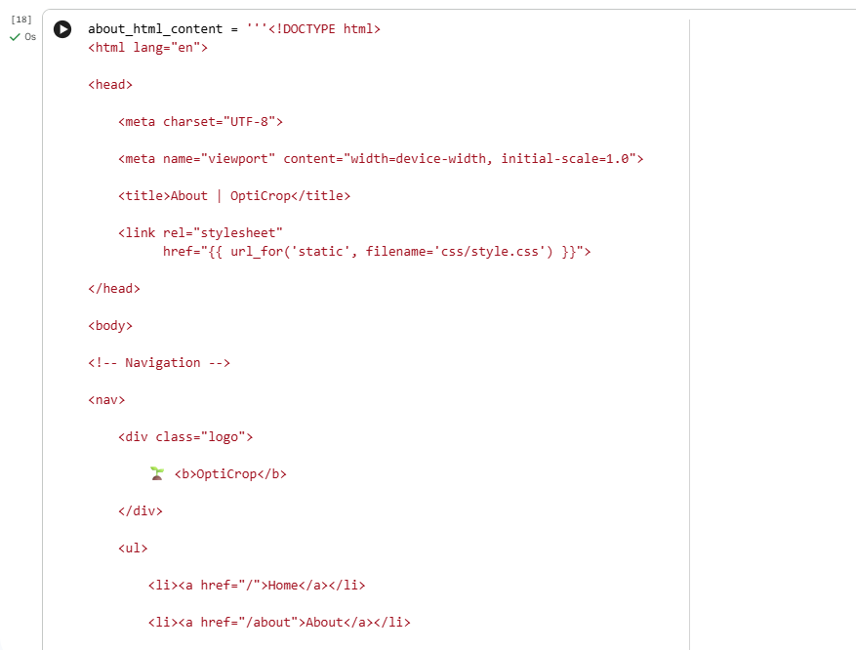
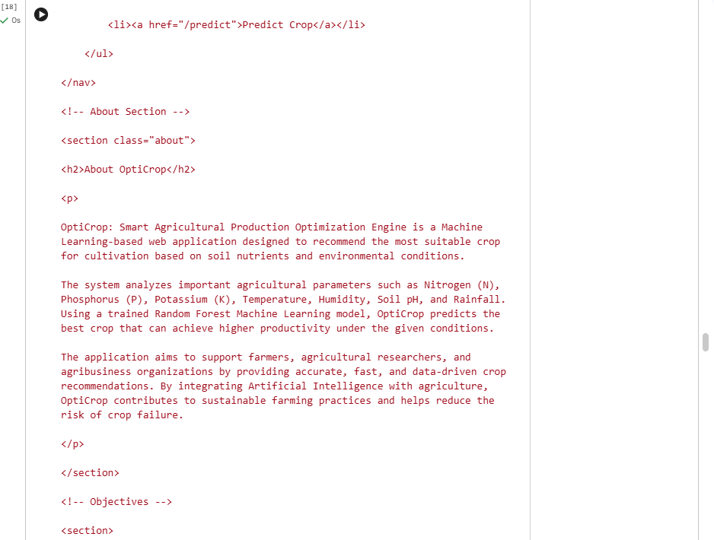
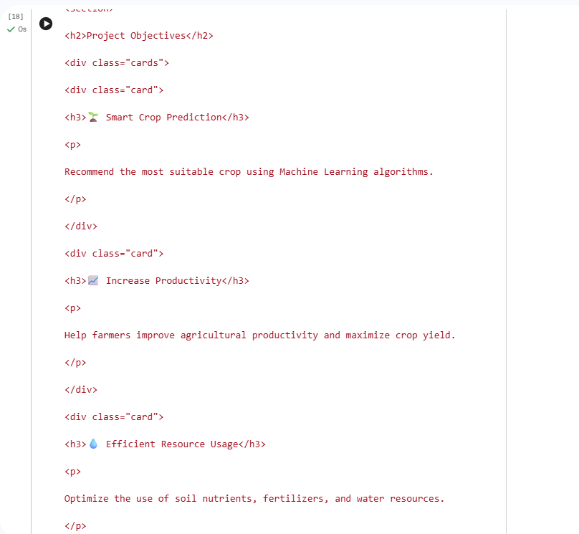
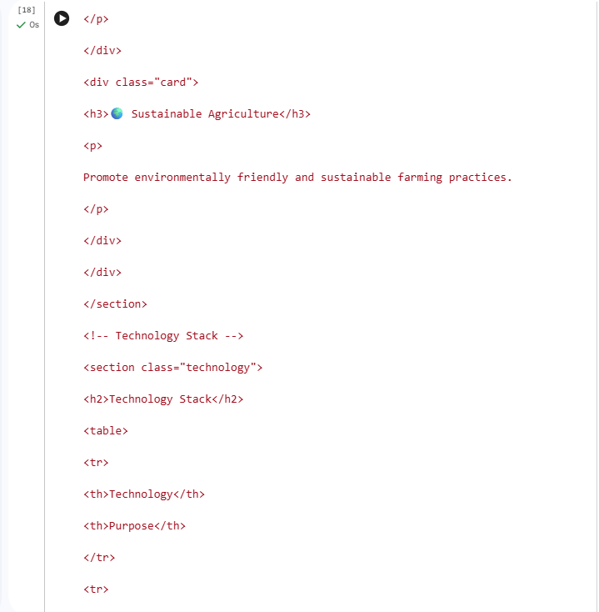
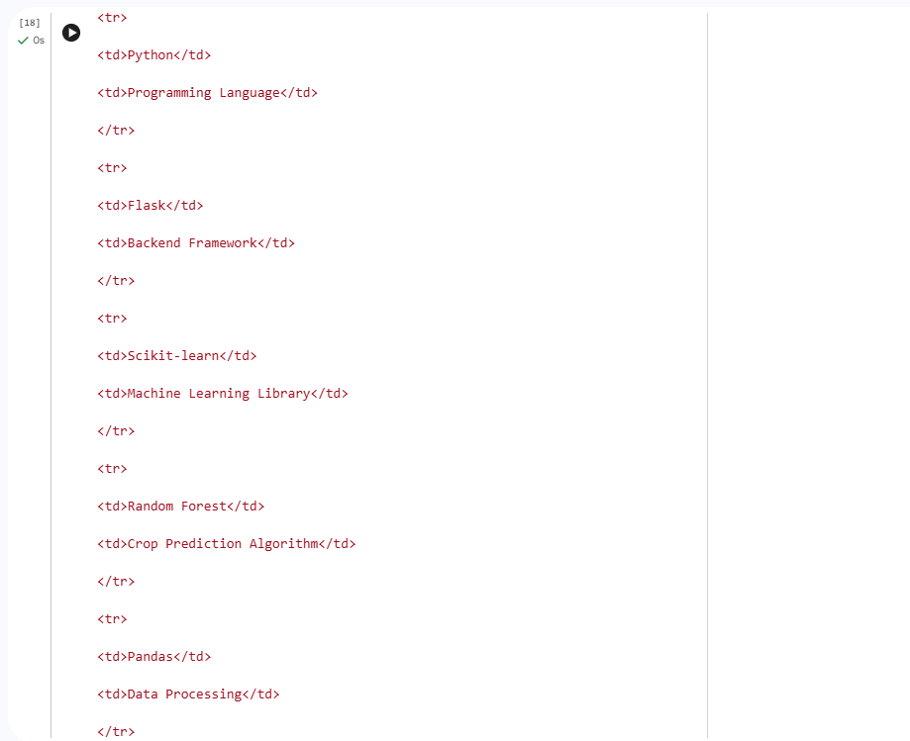
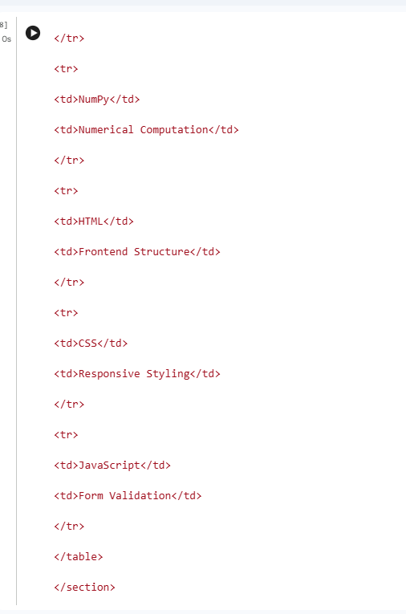
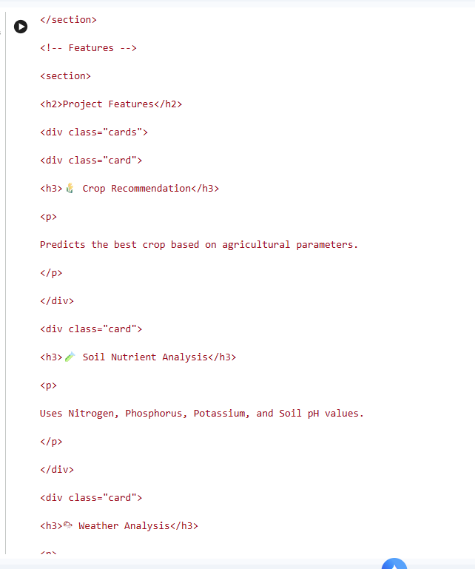
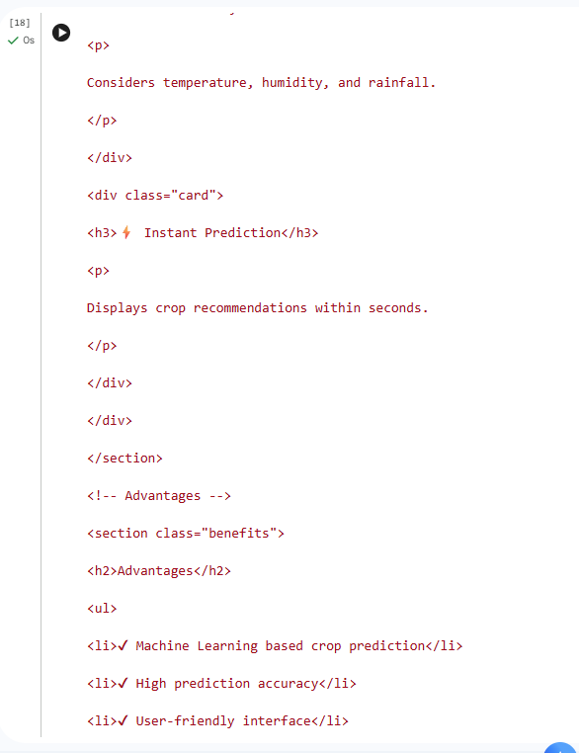

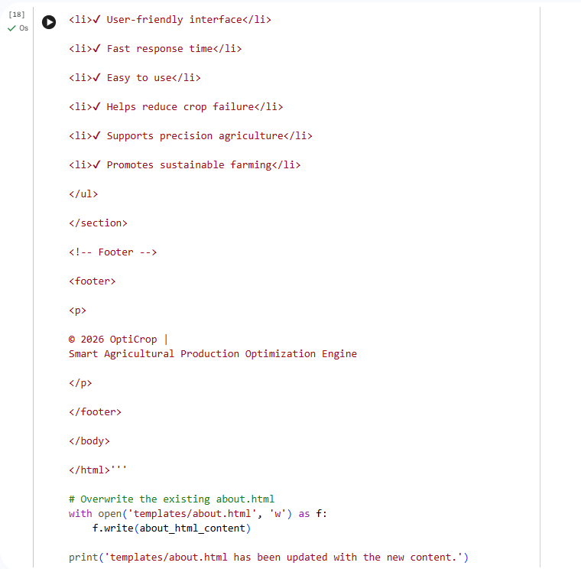

Css file
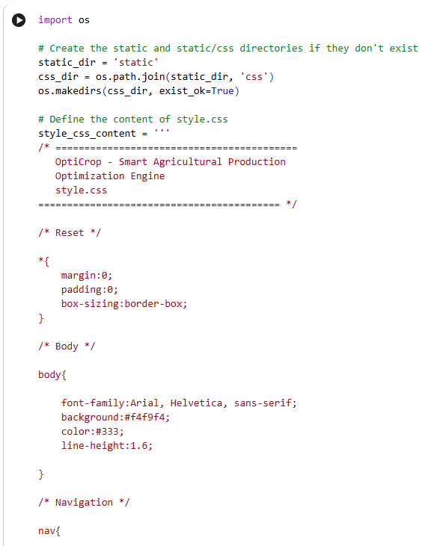
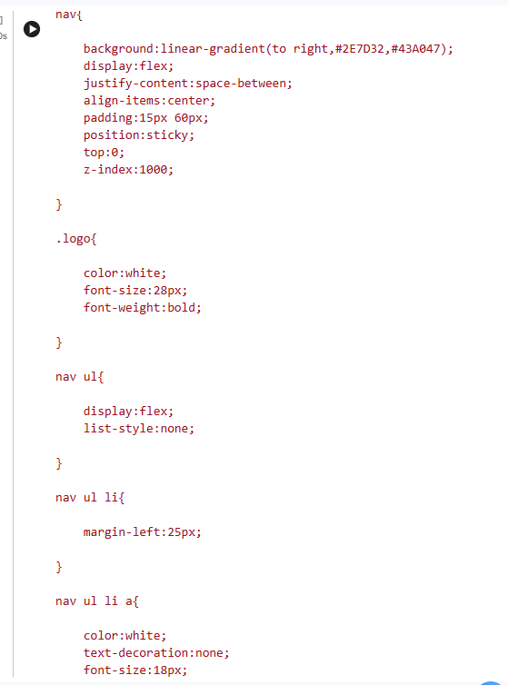
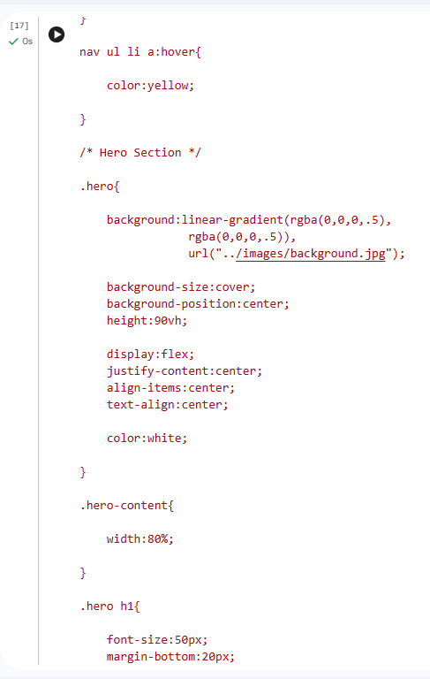
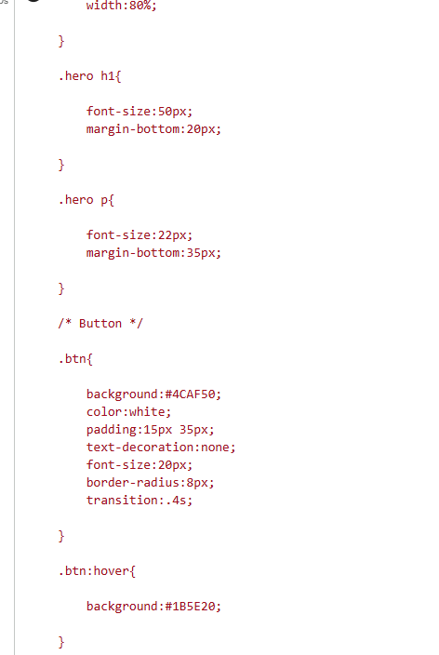
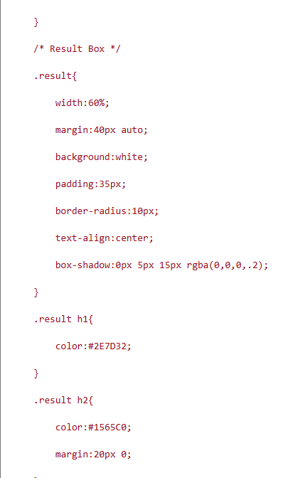
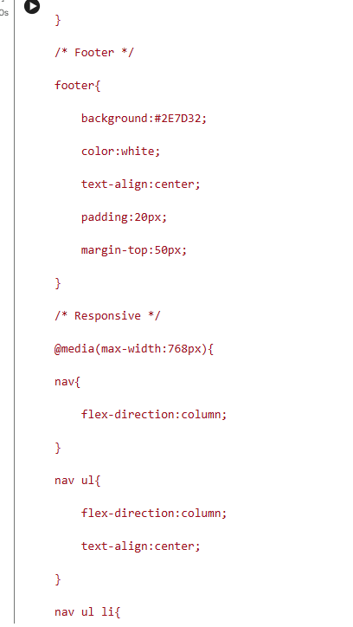
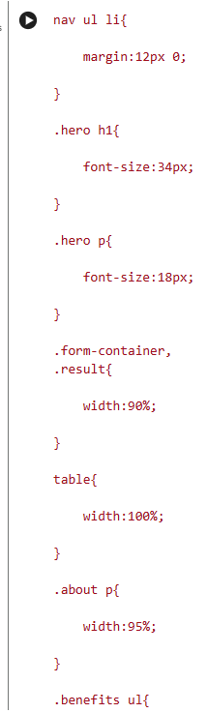
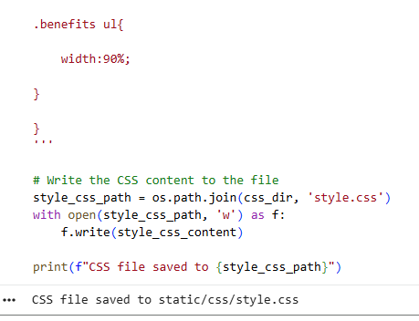
The next file is validation.js. Save this file inside:

OptiCrop/
│
└── static/
└── js/
validation.js
validation.js

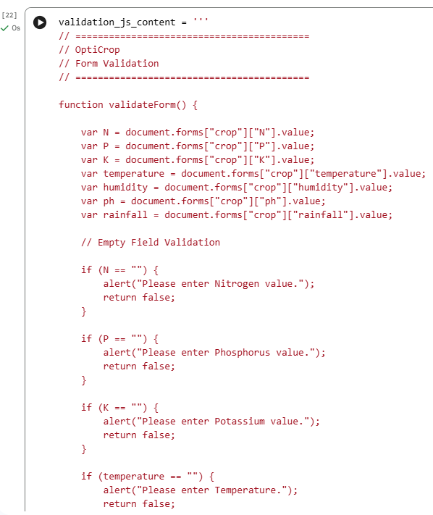
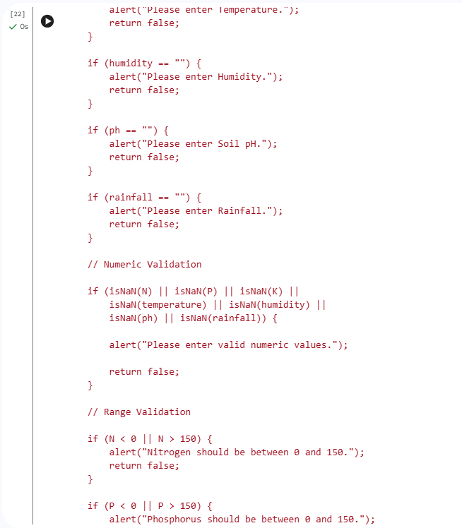
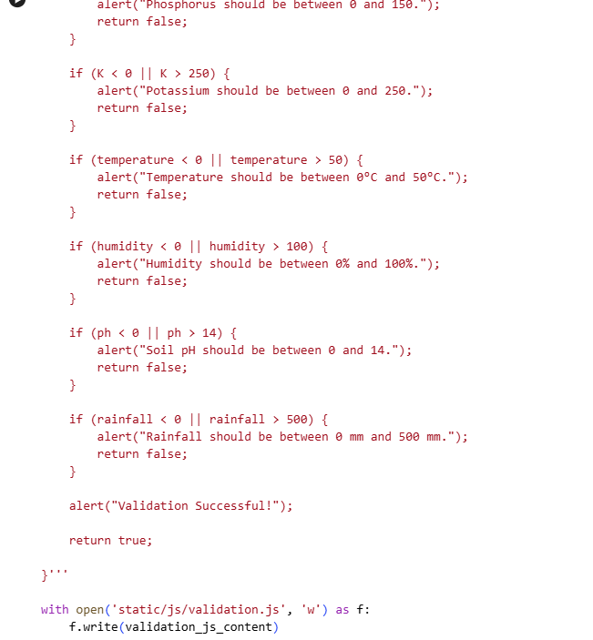
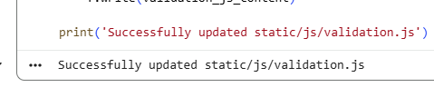
How It Works
Your predict.html already contains:
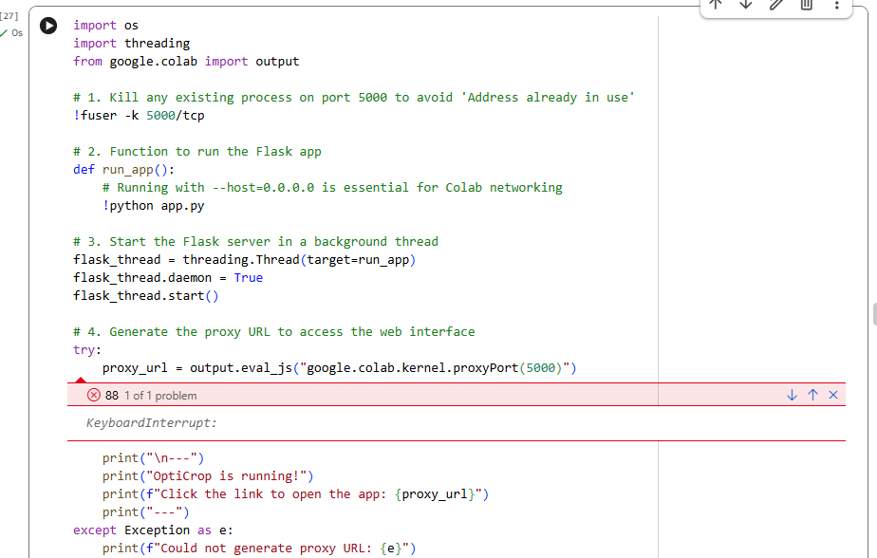
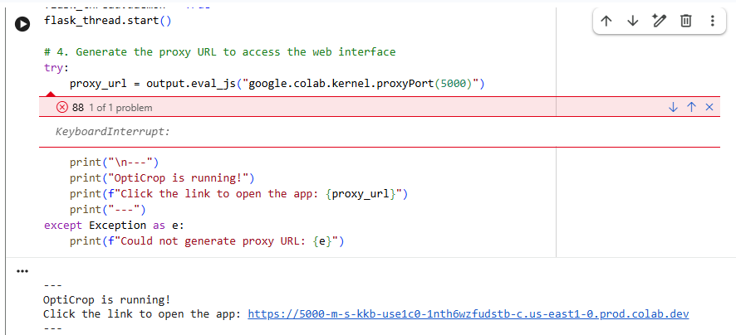
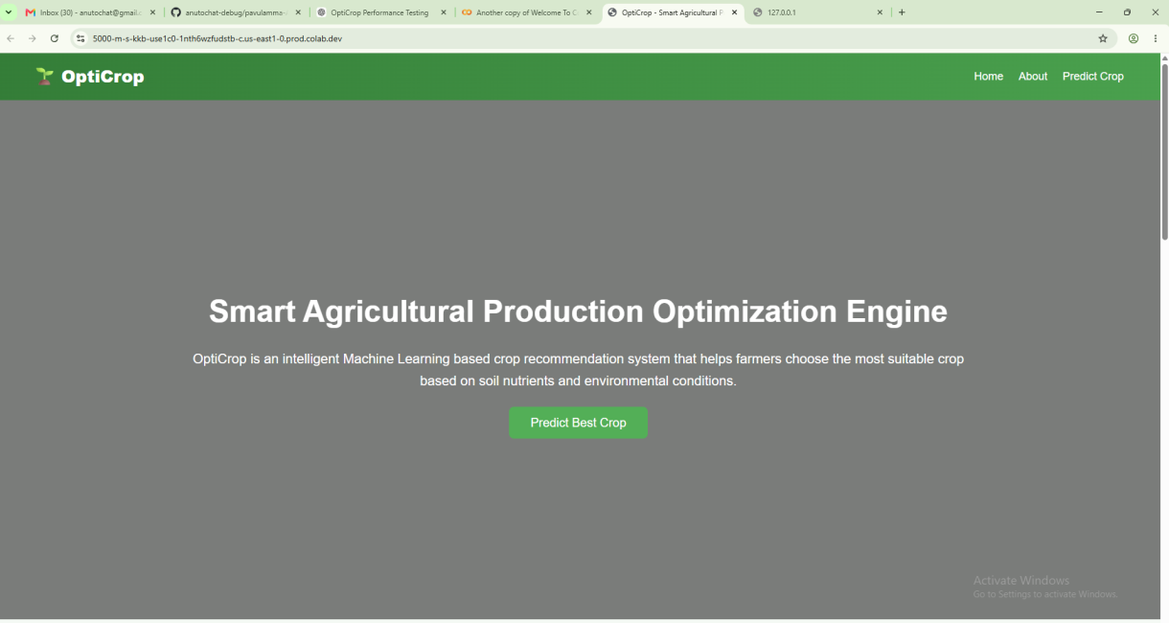
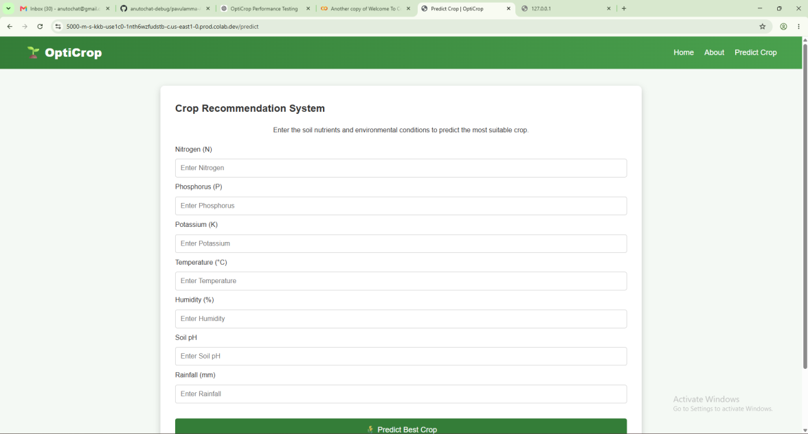
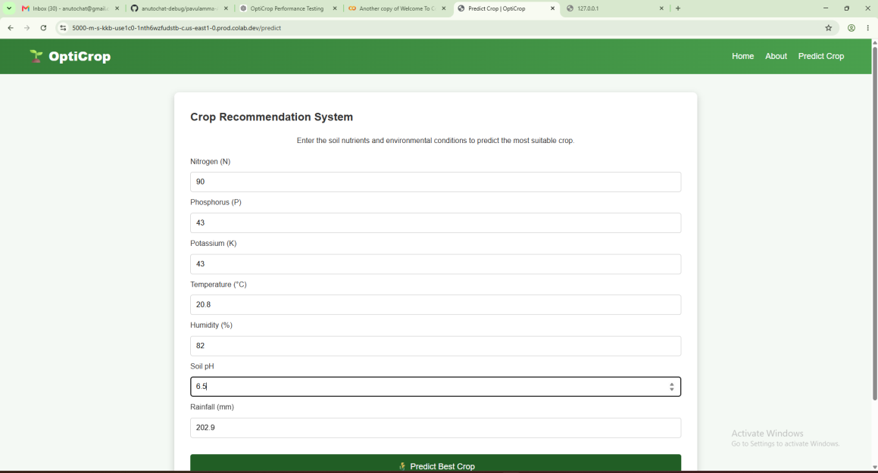

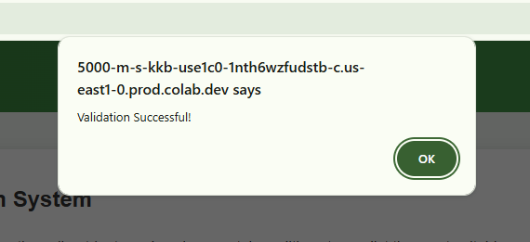
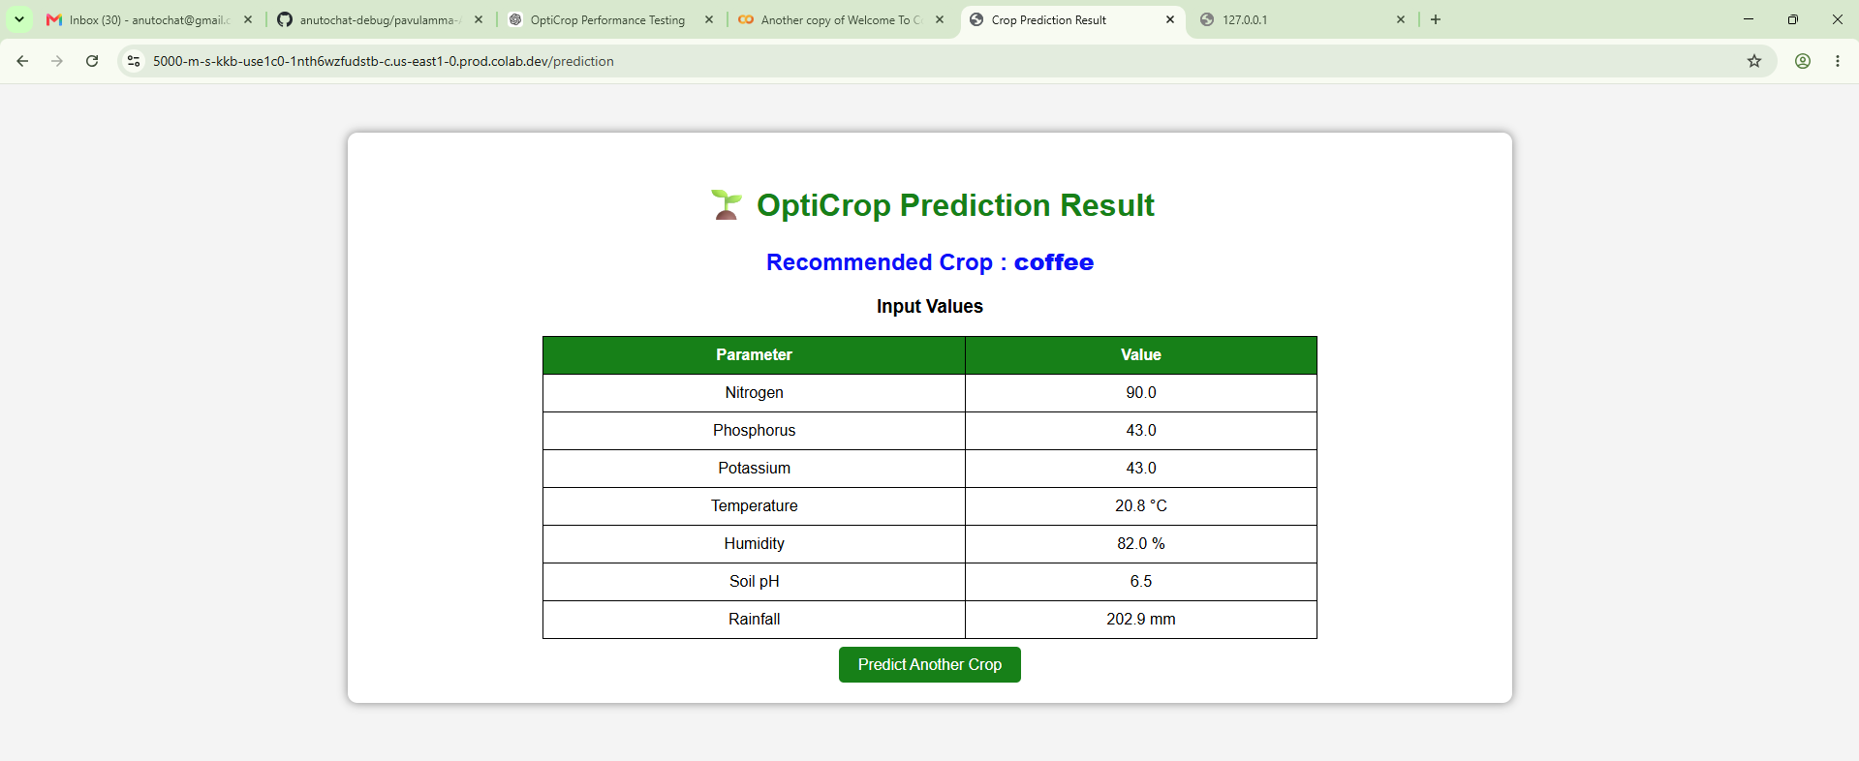
Validation Successful!
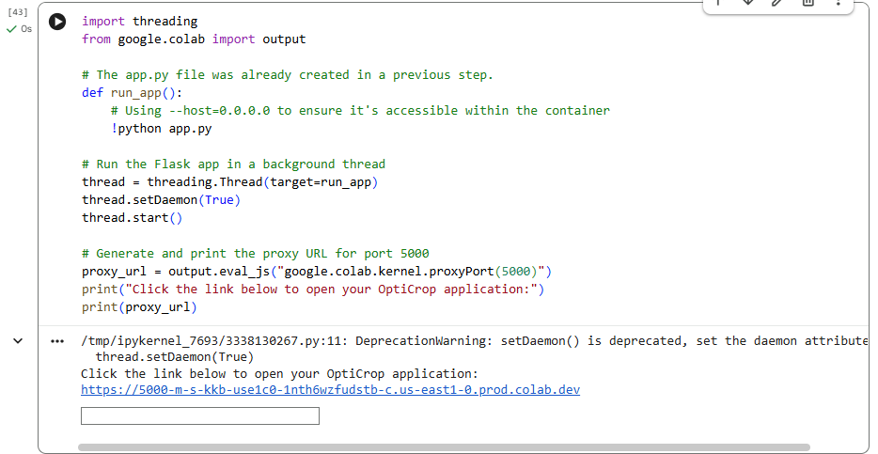

@app.route("/prediction", methods=["POST"])
[ incomplete pandas pd]

Great! Below is the complete result.html for your OptiCrop: Smart Agricultural Production Optimization Engine.
Save this file inside:
OptiCrop/
│
├── templates/
│ result.html

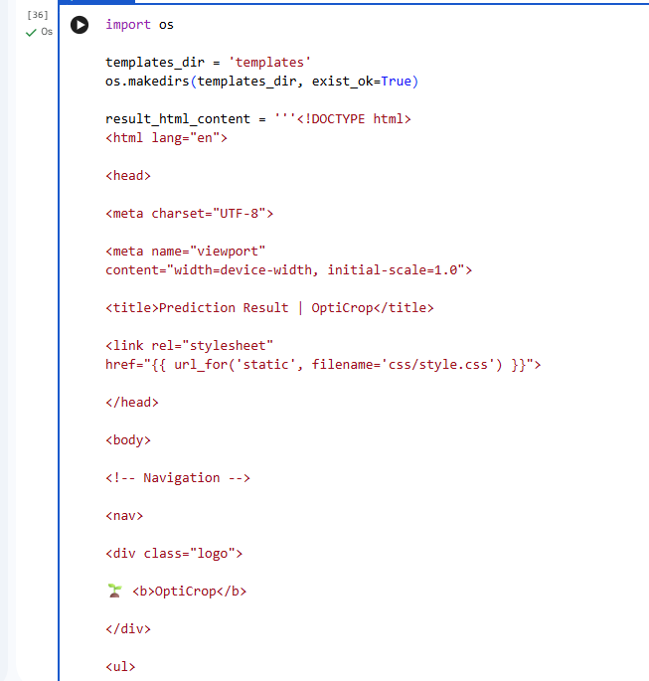
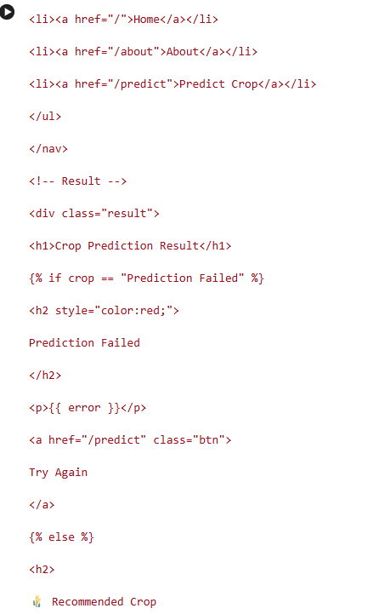
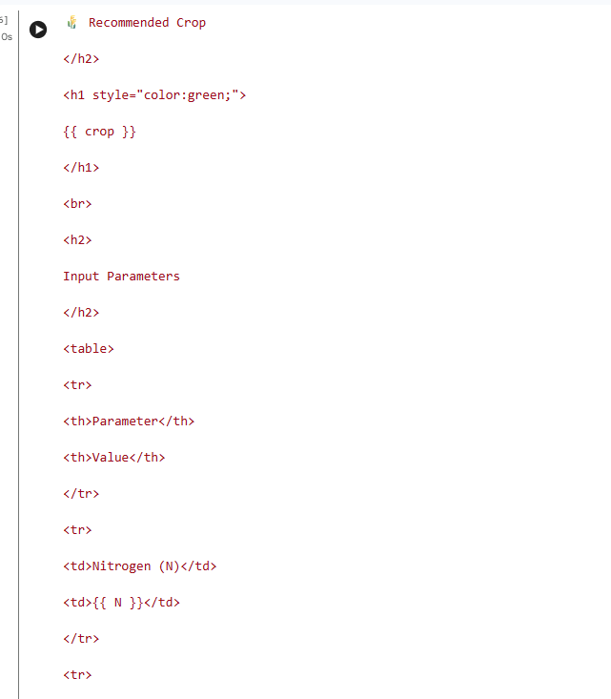
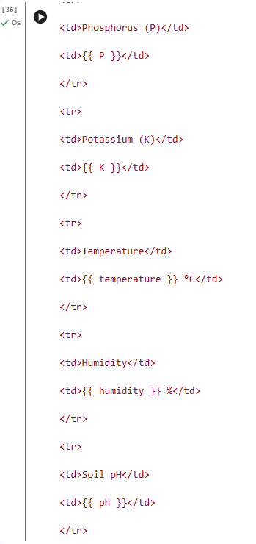
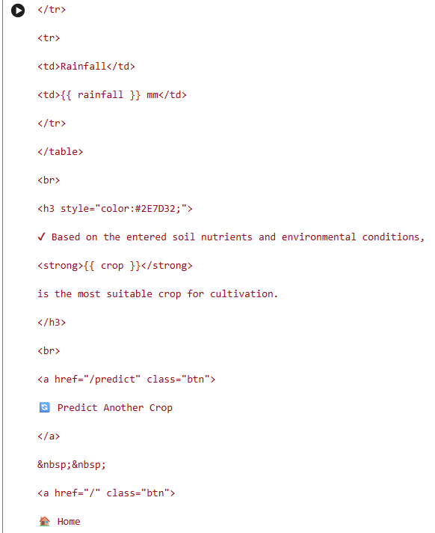
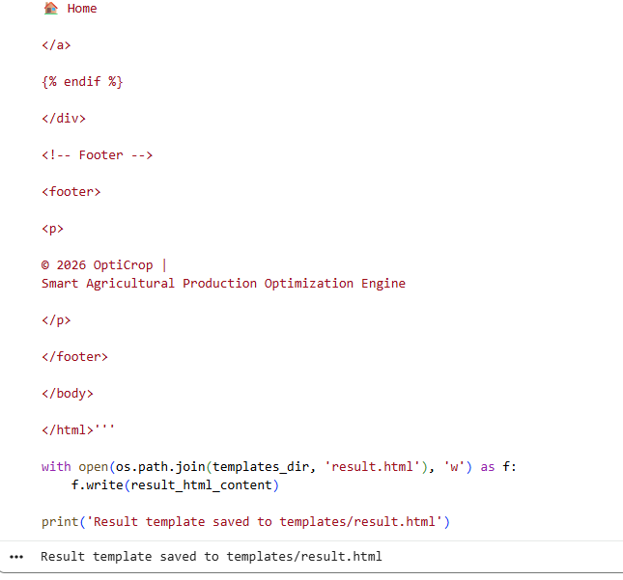

Input
N = 65
P = 55
K = 35
Temperature = 27
Humidity = 68
pH = 6.8
Rainfall = 110

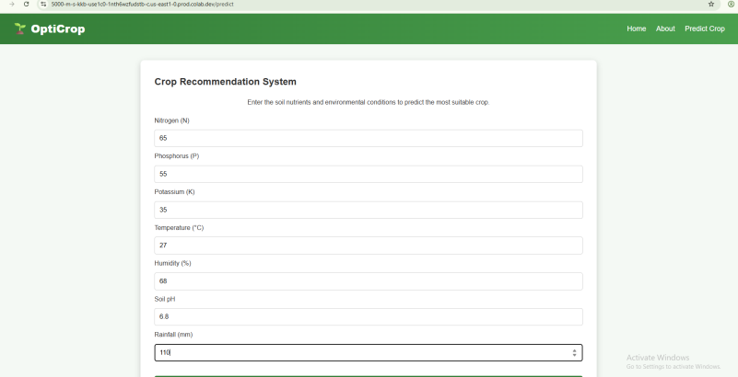
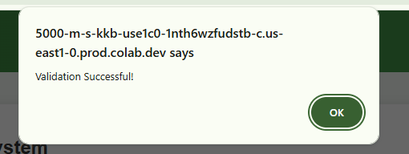
The next file is requirements.txt. This file contains all the Python libraries required to run your OptiCrop: Smart Agricultural Production Optimization Engine.
Save this file in the project root folder.

Folder Structure
OptiCrop/
│
├── app.py
├── train_model.py
├── requirements.txt
├── model.pkl
├── README.md
│
├── dataset/
│ Crop_recommendation.csv
│
├── templates/
│
├── static/

requirements.txt
Flask==3.0.3
numpy==1.26.4
pandas==2.2.2
scikit-learn==1.5.1
scipy==1.13.1
joblib==1.4.2
threadpoolctl==3.5.0
matplotlib==3.9.1
seaborn==0.13.2
pickle-mixin==1.0.2

Install the Required Packages
Open Command Prompt or Terminal in your project folder and run:
pip install -r requirements.txt
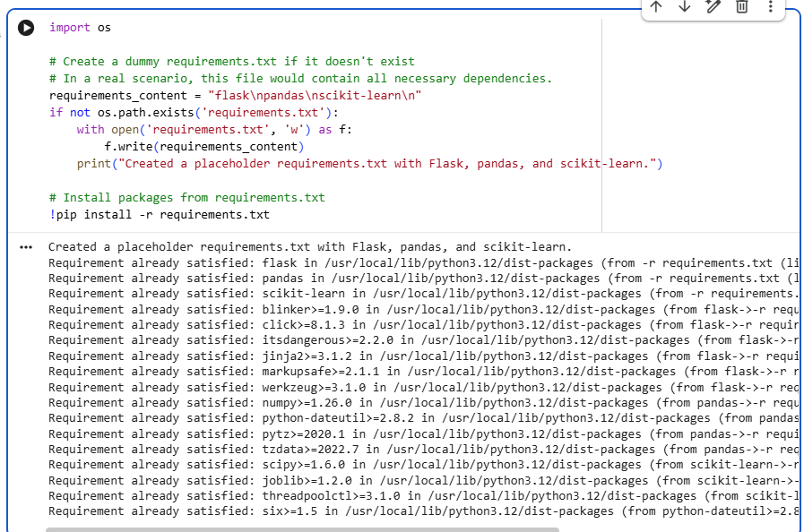

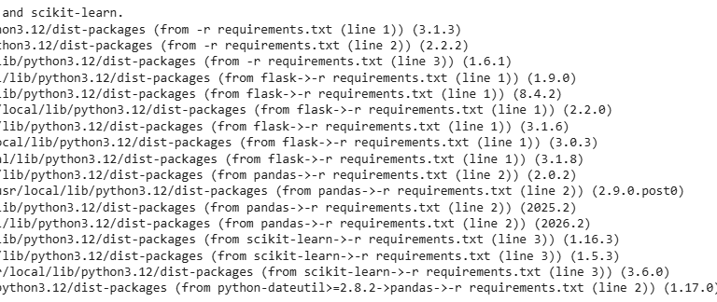

Verify Installation
Run the Flask application:
python app.py
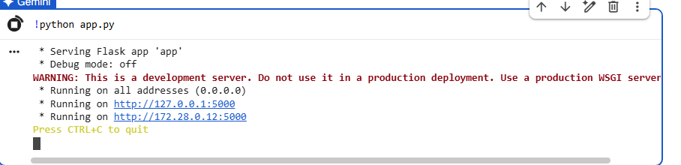
Below is the complete README.md file for your OptiCrop: Smart Agricultural Production Optimization Engine.
Save this file in the root project folder as README.md.
# 🌱 OptiCrop: Smart Agricultural Production Optimization Engine

## Overview
OptiCrop is a Machine Learning-based web application developed to recommend the most suitable crop for cultivation based on soil nutrients and environmental conditions. The system uses a trained Random Forest Classifier to analyze agricultural parameters and predict the best crop for farmers.

The project integrates Machine Learning with Flask to provide an easy-to-use web application that helps farmers make informed decisions and improve agricultural productivity.

---
# Features

- Machine Learning based Crop Recommendation
- User-friendly Flask Web Application
- Predicts crop using:
- Nitrogen (N)
- Phosphorus (P)
- Potassium (K)
- Temperature
- Humidity
- Soil pH
- Rainfall
- Responsive Web Interface
- Input Validation using JavaScript
- Attractive UI using HTML & CSS
- High Prediction Accuracy

---

# Technology Stack

## Frontend

- HTML5
- CSS3
- JavaScript

## Backend

- Python
- Flask

## Machine Learning

- Scikit-learn
- Random Forest Classifier

## Libraries

- NumPy
- Pandas
- Pickle

---

# Project Structure

OptiCrop/

│

├── app.py

├── train_model.py

├── model.pkl

├── requirements.txt

├── README.md

│

├── dataset/

│ └── Crop_recommendation.csv

│

├── templates/

│ ├── index.html

│ ├── about.html

│ ├── predict.html

│ └── result.html

│

├── static/

│ ├── css/

│ │ └── style.css

│ │

│ ├── js/

│ │ └── validation.js

│ │

│ └── images/

│ └── background.jpg

---

# Dataset

Dataset Name

Crop_recommendation.csv

Dataset Features

- Nitrogen
- Phosphorus
- Potassium
- Temperature
- Humidity
- pH
- Rainfall
- Label (Crop)

---

# Machine Learning Algorithm

The project uses the **Random Forest Classifier** because it provides:

- High Accuracy
- Fast Prediction
- Robust Performance
- Better Generalization

---

# Installation

## Step 1

Clone or Download the Project

```
git clone https://github.com/yourusername/OptiCrop.git
```

or simply download the project folder.

---

## Step 2

Install Required Packages

```
pip install -r requirements.txt
```

---

## Step 3

Train the Model

```
python train_model.py
```

This creates

```
model.pkl
```

---

## Step 4

Run Flask Application

```
python app.py
```

---

## Step 5

Open Browser

```
http://127.0.0.1:5000
```

---

# Sample Input

| Parameter | Value |
|------------|-------|
| Nitrogen | 90 |
| Phosphorus | 42 |
| Potassium | 43 |
| Temperature | 20.8 |
| Humidity | 82 |
| Soil pH | 6.5 |
| Rainfall | 202.9 |

---

# Sample Output

```
Recommended Crop

Rice
```

---

# Another Example

Input

```
N = 20

P = 30

K = 25

Temperature = 18

Humidity = 62

pH = 7.1

Rainfall = 85
```

Output

```
Recommended Crop

Wheat
```

---

# Another Example

Input

```
N = 65

P = 55

K = 35

Temperature = 27

Humidity = 68

pH = 6.8

Rainfall = 110
```

Output

```
Recommended Crop

Maize
```

---

# Project Workflow

1. Load Dataset

↓

2. Data Preprocessing

↓

3. Train Random Forest Model

↓

4. Save Model as model.pkl

↓

5. Load Model in Flask

↓

6. User Enters Soil Data

↓

7. Model Predicts Crop

↓

8. Display Result

---

# Screens

### Home Page

- Navigation Bar
- Project Introduction
- Features
- Start Prediction Button

### About Page

- Project Description
- Objectives
- Technology Stack
- Advantages

### Prediction Page

- User Input Form
- Validation
- Predict Button

### Result Page

- Recommended Crop
- Input Values
- Predict Again Button

---

# Future Enhancements

- Fertilizer Recommendation
- Crop Disease Prediction
- Weather API Integration
- Soil Sensor Integration
- Mobile Application
- Cloud Deployment
- Multilingual Support
- IoT Based Smart Farming

---

# Advantages

- Easy to Use
- Fast Prediction
- Accurate Results
- Supports Farmers
- Sustainable Agriculture
- Resource Optimization

---

# Conclusion

OptiCrop is an intelligent Machine Learning-powered agricultural decision support system that recommends the most suitable crop using soil nutrients and environmental conditions. The project combines Flask, Python, and Random Forest Machine Learning to deliver accurate predictions through a simple and responsive web interface. It helps improve crop selection, optimize agricultural resources, and promote sustainable farming practices.

---
# Author

Project Name

OptiCrop: Smart Agricultural Production Optimization Engine

Developed Using

Python

Flask

HTML

CSS

JavaScript

Scikit-learn

Machine Learning

Random Forest Classifier

---
© 2026 OptiCrop Project
All Rights Reserved.
This is a complete Flask + Machine Learning crop recommendation application.

